**IP Desktop Phone Production Check Report for Next media Services**

**Objective:**

To assess the readiness of IP desktop phones for deployment in Next media Services.

**Scope:**

Inspection of hardware, software configurations, network compatibility, and overall functionality.

1. **Hardware Inspection**

- Verify physical condition of phones (e.g., screen, buttons, ports).

- Ensure power supply and cabling integrity.

- Confirm phone models match production requirements.

**2. Software & Configuration**

- Validate firmware versions are up-to-date.

- Check provisioning settings (SIP accounts, server settings).

- Ensure compliance with company security standards (e.g., encryption, authentication).

3. **Network & Connectivity**

- Test IP addresses are correctly assigned via DHCP.

- Confirm phones are registering with the VoIP server.

- Perform voice quality checks.

4. **Functional Testing**

- Make and receive test calls.

- Check voicemail, call forwarding, and other key features.

- Assess speaker and microphone performance.

5. **Documentation & Labeling**

- Document all phone configurations for future reference.

- Label phones with asset tags for tracking.

HERE THE MAINTENANCE WAS TAKING PLACE

ONE OF SAMPLE HAVE BEEN WORKED ON……….

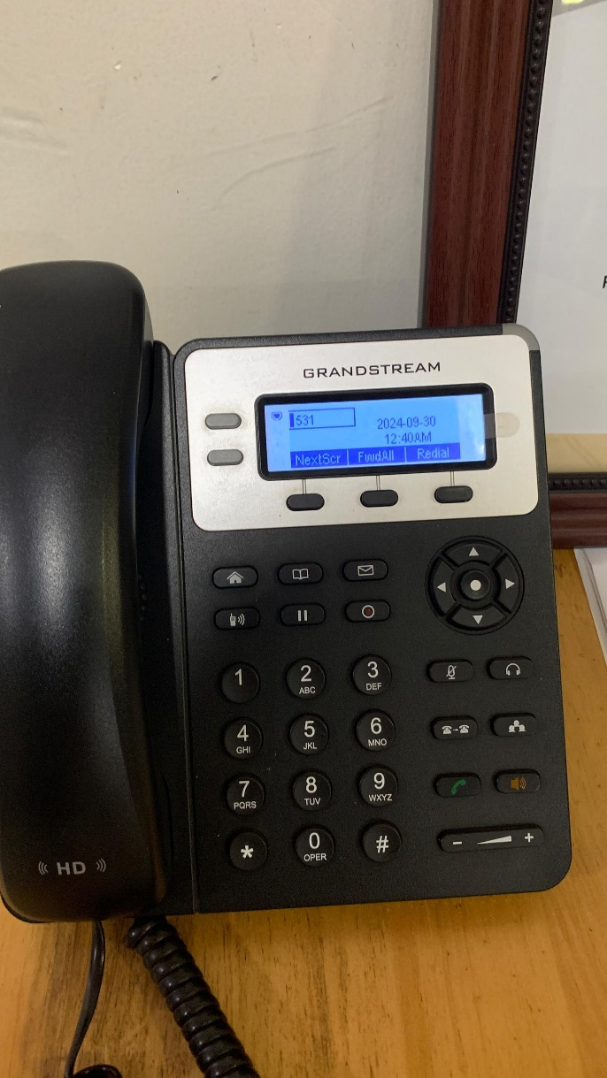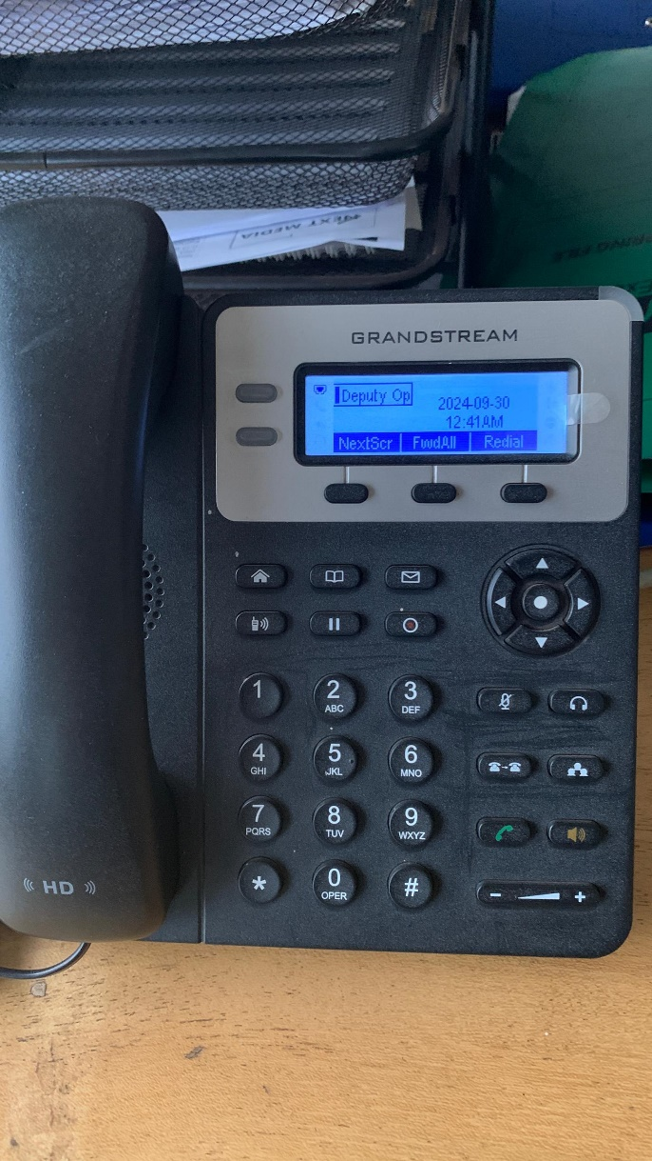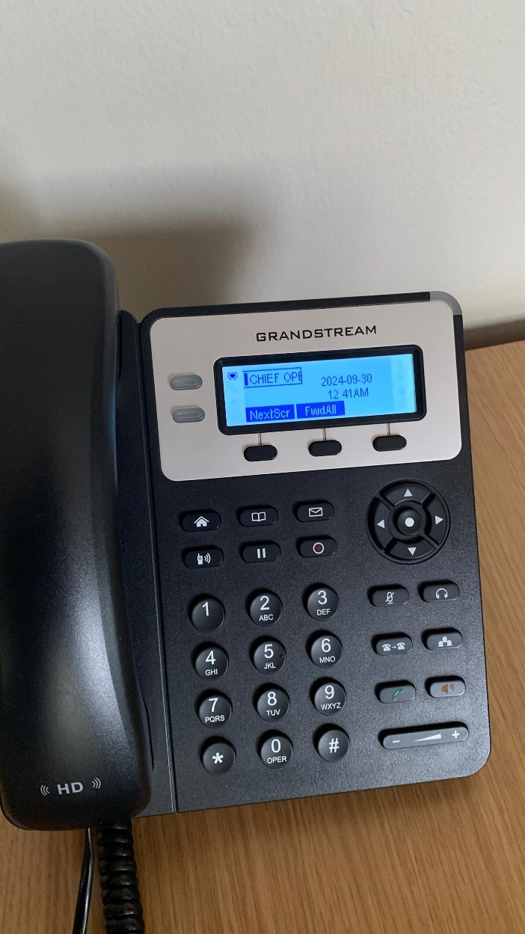

**Conclusion:**

Once all checks are complete, phones are ready for deployment in production.